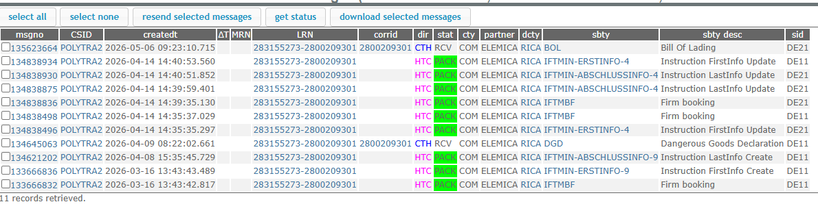
IFCSUM - 2013354401
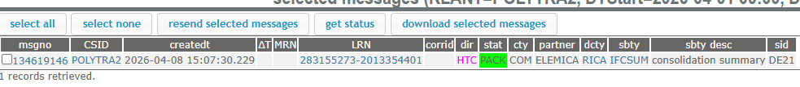
IFCSUM – 2013354402
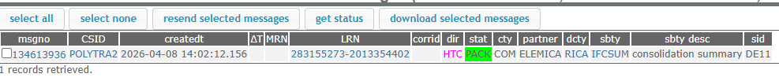
IFCSUM – 2013354403
